|  |  |  |  |
| --- | --- | --- | --- |
| 1 | This is Scene 1 of the game. At the start, it will have the masking load from left to right. | 2 | This is Scene 1 of the game. The Apple logo will drop from top to bottom. |
|  |  |  |  |

3 4

This is Scene 1 of the game. The word JOIN US will rotate from left to the middle and the word will delay for 1 sec before the staff image appear.

This is Scene 1 of the game. The word LOOKING FOR A JOB ? will rotate from left to the middle and the word will delay for 1.5 sec before the word JOIN US appear.

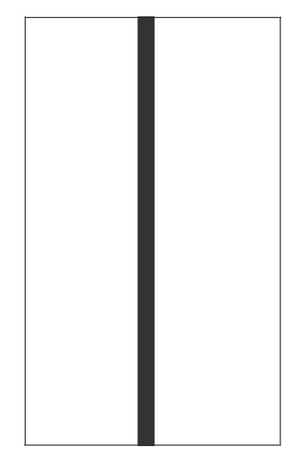5

6

This is Scene 2 of the game. At the start, it will have the masking start from right to left.

This is Scene 1 of the game. The staff image will pop up from the outside the box to the bottom of the screen.

7

8

This is Scene 2 of the game. The staff image will fade in.

This is Scene 2 of the game. The word COME TO APPLE will fade in and the word will delay for 1 sec before the word GATHER TOGETHER TO PAVE THE WAY TO INNOVATION appear.

9.

This is Scene 2 of the game. The word GATHER TOGETHER TO PAVE THE WAY TO INNOVATION will fade in and the word will delay for 1 sec before the button CLICK HERE appear.

This is Scene 2 of the game. The button CLICK HERE will fade in and the button will link to the Job at Apple website.

10.